AMOGH M.K.

01FB15EEC027

Implementation of Ctrl+L shortcut to clear terminal in xv6 OS

**INTRODUCTION**

Ctrl+L is the keyboard shortcut to clear the terminal screen in standard UNIX computer operating system. It is the equivalent of the command ‘clear’ which removes all previous commands and outputs from consoles / terminals. On pressing Ctrl+L, only the command prompt remains on the display screen in the upper left hand corner.

Users usually invoke this shortcut so that it is easier to focus on understanding subsequent commands and their output.

**OVERVIEW**

To clear both qemu and Ubuntu terminals by implementing the Ctrl+L shortcut.

qemu (quick emulator):

It is a hosted virtual machine monitor which is used to run/emulate a variety of unmodified guest operating systems (in this case xv6 OS).

**MODIFICATION OF FILE ‘console.c’**

Some variables are declared in the beginning of ‘consoleintr’ function declaration. They are:

int i, pos;

char d;

char a[]="\033[2J\033[1;1H";

// this string gives ANSI escape codes.

// (\033[2J) - clears the entire screen from top to bottom, move to position (0,0).

// (\033[1;1H) - positions cursor at row 1, column 1.

In the declaration of function ‘consoleintr’, case C(‘L’) was added to the switch statement which is shown below:

case C('L'):

i=0;

//clearing Ubuntu terminal

//resets the cursor of Ubuntu terminal to top-left

while (i<14)

{

d=a[i];

uartputc(d); //writing to Ubuntu terminal

i++;

}

//clearing qemu

//screen resolution of terminal is 24*80.Print 24 newlines

i=0;

while (i<=24)

{

cgaputc('\n'); //writing to qemu

i=i+1;

}

//shifting cursor position in qemu

//outb header in x86.h

pos=0;

outb(CRTPORT, 14);

outb(CRTPORT+1, pos>>8);

outb(CRTPORT, 15);

outb(CRTPORT+1, pos);

cgaputc('$');

cgaputc(' ');

uartputc('$');

uartputc(' ');

break;

**RESULT**

Before invoking shortcut Ctrl+L:

Qemu terminal:

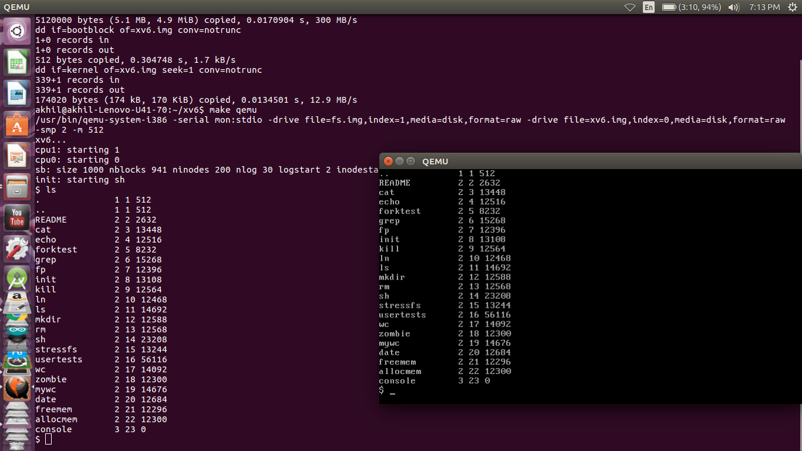

Ubuntu terminal:

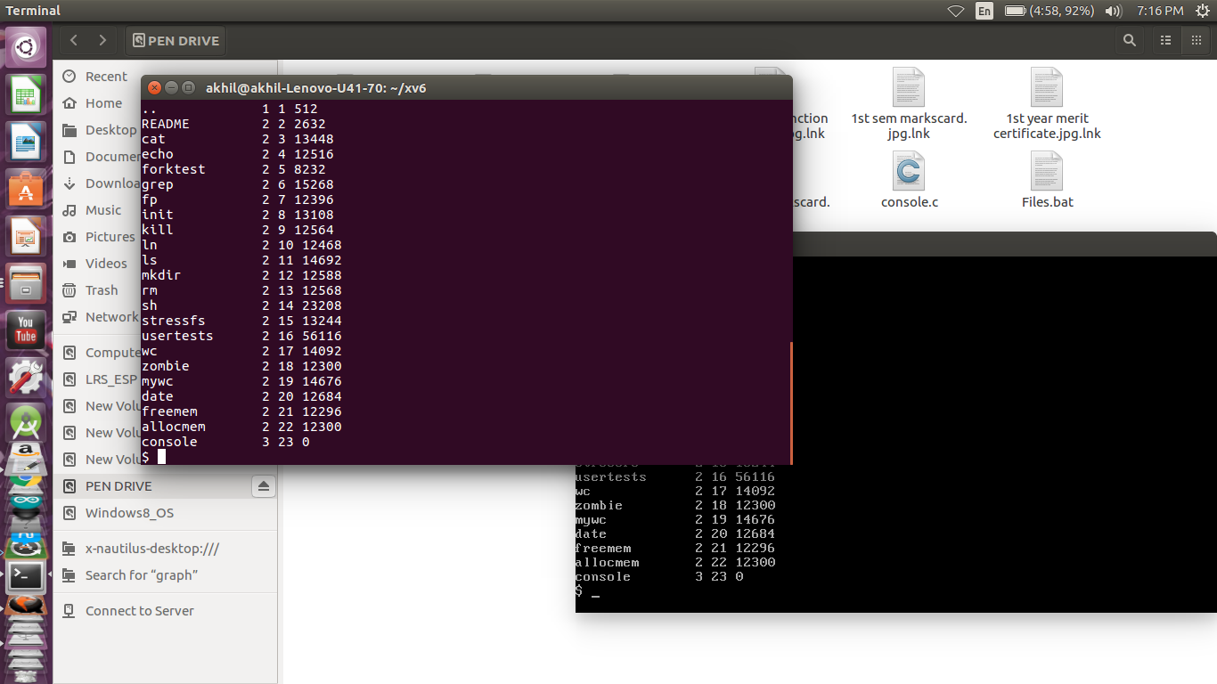

After invoking shortcut Ctrl+L:

Qemu terminal:

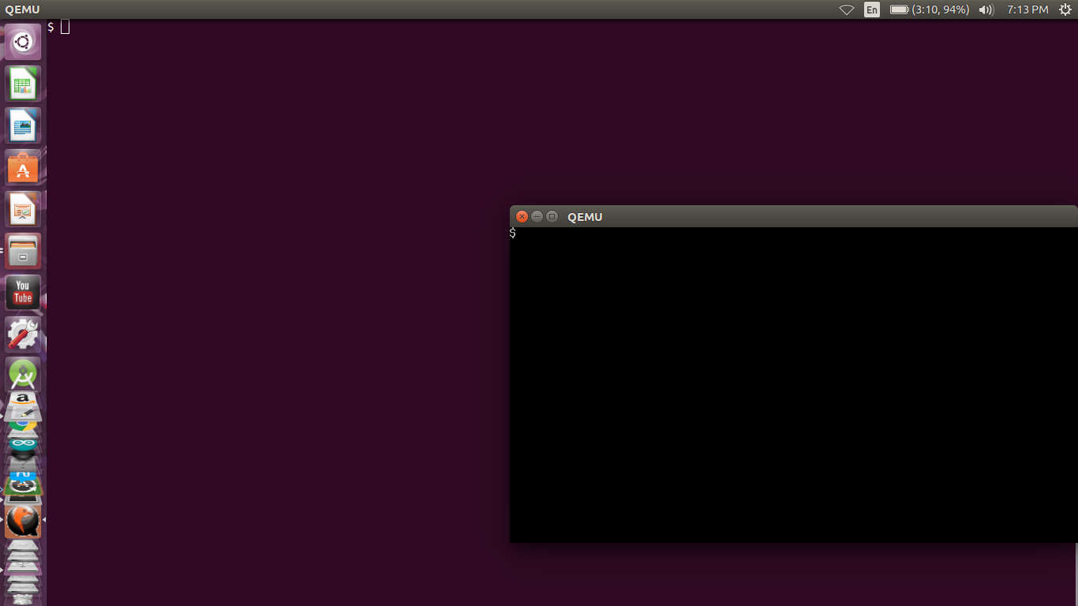

Ubuntu terminal:

